Dummy Test Report
USER STORY
As a shopper, I want to search the catalog, add a product to my cart, and complete checkout, so that i can buy what i came for and the team can prove that the journey on every build

Scenarios
1) Buy a single product end to end @smoke
2) Cart Badge reflects the number of items added @smoke
3) Buy across several products via one Scenario Outline @regression
4) A fresh cart is empty(O line items) - valid empty state @regression
5) One deliberately failing scenario to demonstrate the failure screenshot @negative (5)

Project Structure
src/test/java/bdd/
- Hooks.java
- TestStep.java
- World.java
- Test.java
src/test/java/pages/
- CatalogPage.java
- ProductPage.java
- CartPage.java
- CheckoutPage.java
src/test/java/support/
- DriverFactory.java
- Config.java
- TestEnvironment.java
src/test/resources/
- features/checkout.feature
- allure.properties
- extent.properties
- junit-platform.properties

How to run:
mvn clean test
The above will run the @smoke codes because in junit-platform.properties i added cucumber.filter.tags = @smoke this will result only in @result cucumber

mvn -Dtest=Test -Dcucumber.filter.tags=”@regression” will only run the regression tagged test

Test Cases
User Story: As a shopper, I want to search the catalog, add a
product to my cart, and complete checkout so that I can buy what
I came for, and the team can verify the entire customer journey
with every new build.

Given the catalog is open
When I search for "<product>"
And I add the first result to the cart
Then the cart badge shows <count>
When I open the cart
Then the cart has <count> line items
When I place the order
Then the order is confirmed

Tags Used
- @smoke : Critical path checks
- @regression : Full regression coverage
- @negative : Negative scenarios

ENVIRONMENT CONFIGURATION

Driver : DRIVER=chrome
Headed Mode : HEADLESS=false
Base URL : baseUrl=website url

Configuration can be supplied through .env file.

TEST EXECUTION COMMANDS
mvn test -DHEADLESS=true -DDRIVER=chrome

- Smoke Tests
mvn test -Dcucumber.filter.tags="@smoke" -DHEADLESS=true -DDRIVER=chrome

- Regression Tests
mvn test -Dcucumber.filter.tags="@regression" -DHEADLESS=true -DDRIVER=chrome

- Regression Tests Without Negative Tests
mvn test -Dcucumber.filter.tags="@regression and not @negative" -DHEADLESS=true -DDRIVER=chrome

Extent Spark Report Summary for @smoke test

Failure Screenshot (if applicable)
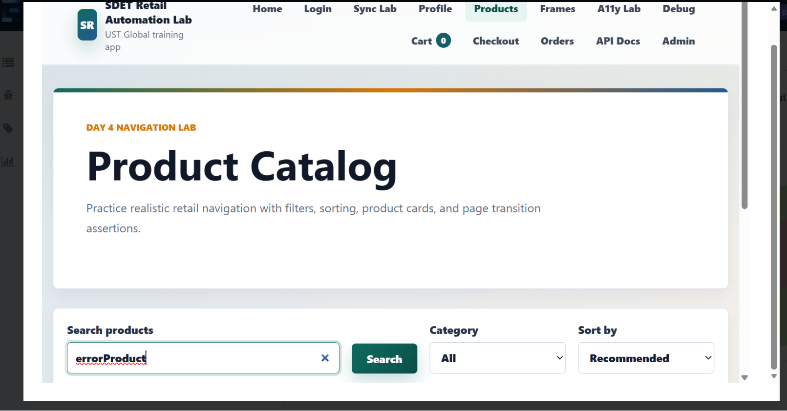
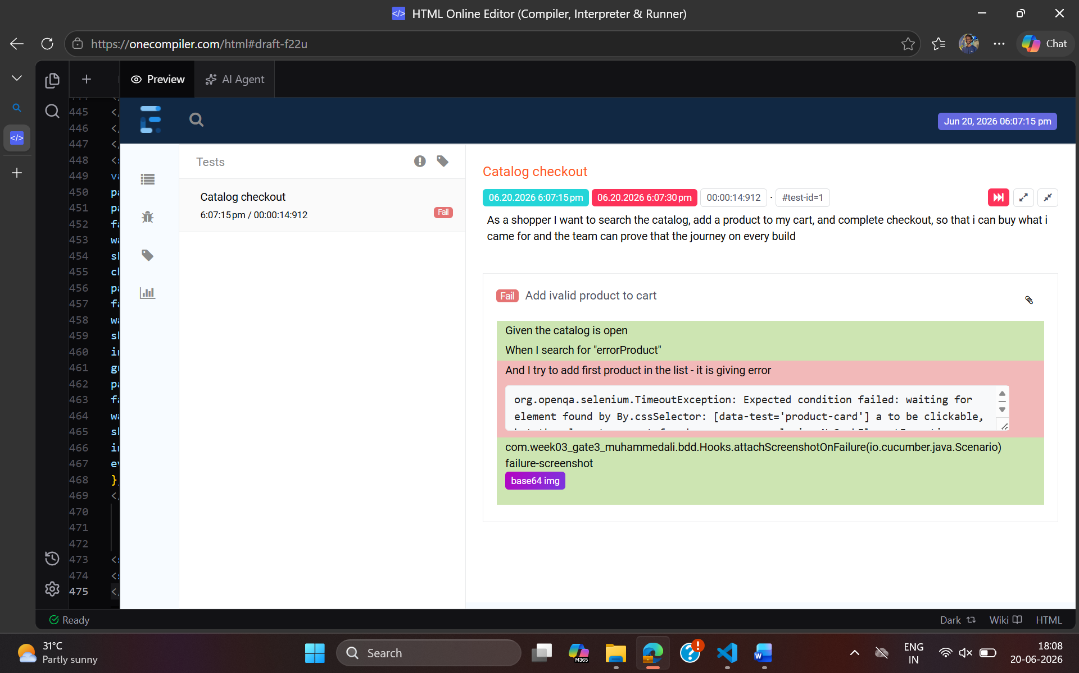

REPORTING
Allure Report
Results stored in: target/allure-results
Generate with: allure serve target/allure-results

Extent Spark Report
Report location: test-output/SparkReport/Spark.html
Open this HTML file after the tests finish.

Test and screenshots
>mvn clean test
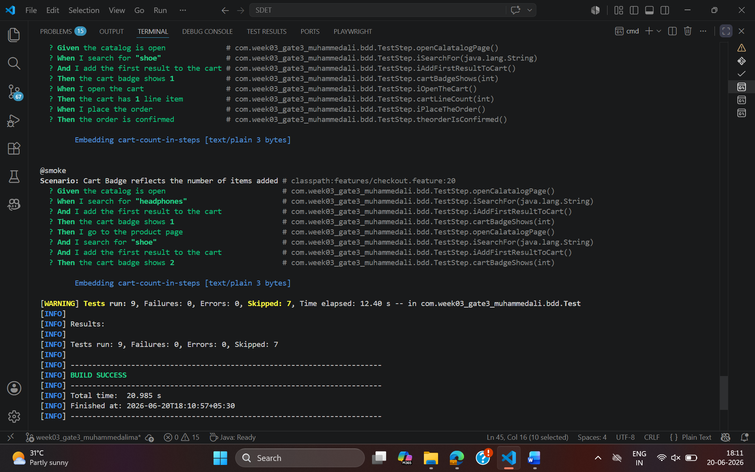
mvn clean test -Dcucumber.filter.tags="@regression"
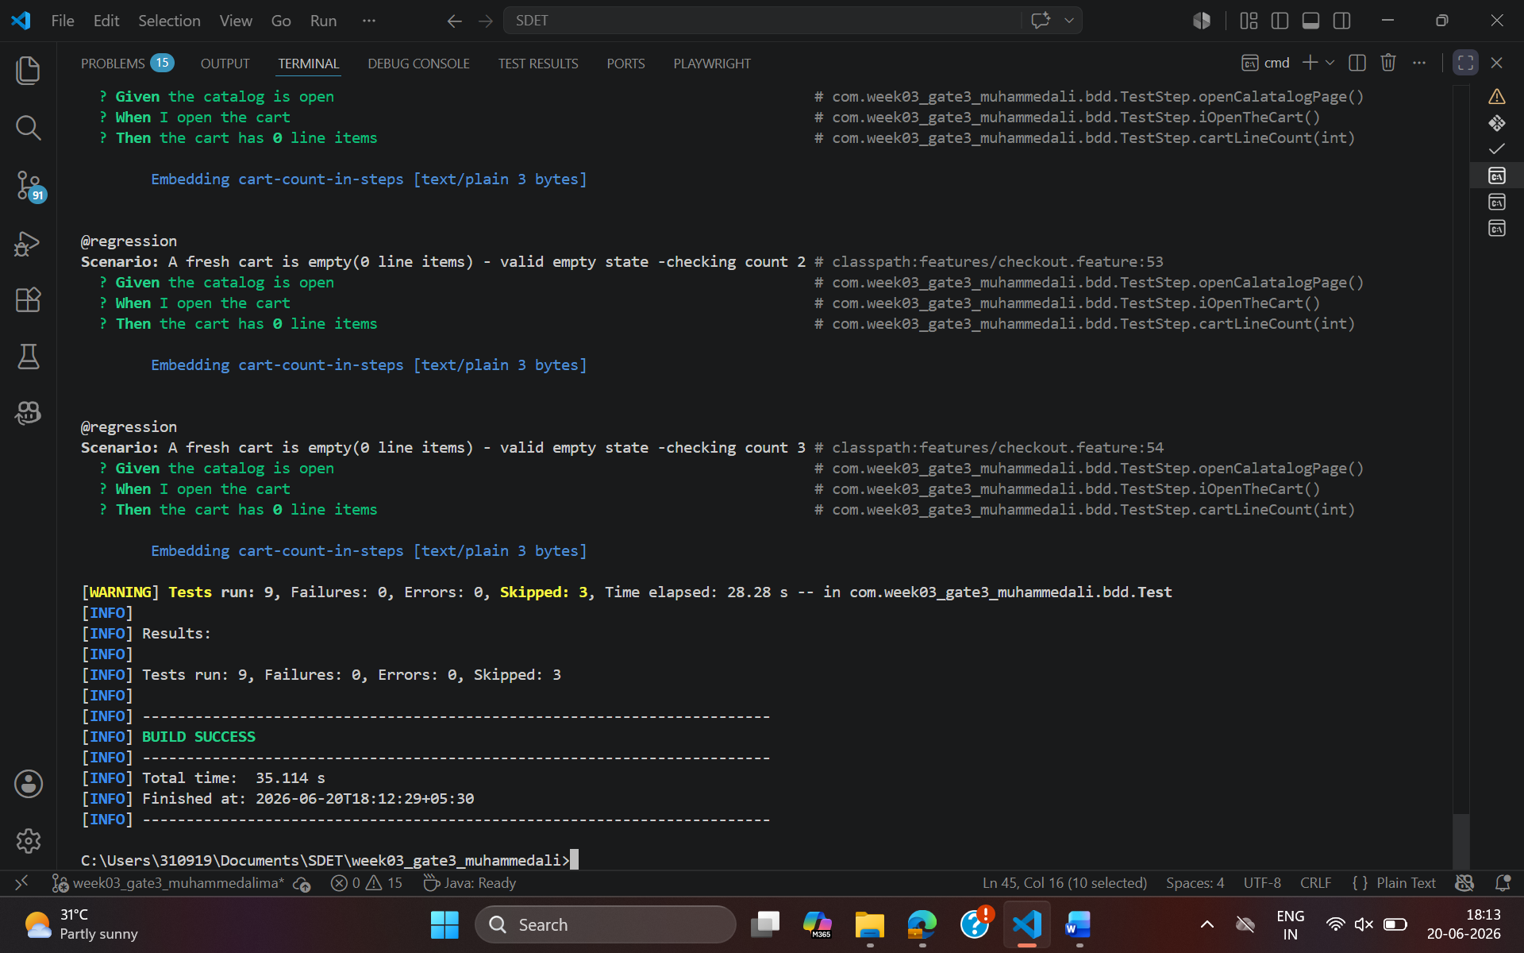

mvn clean test -Dcucumber.filter.tags="@negative"
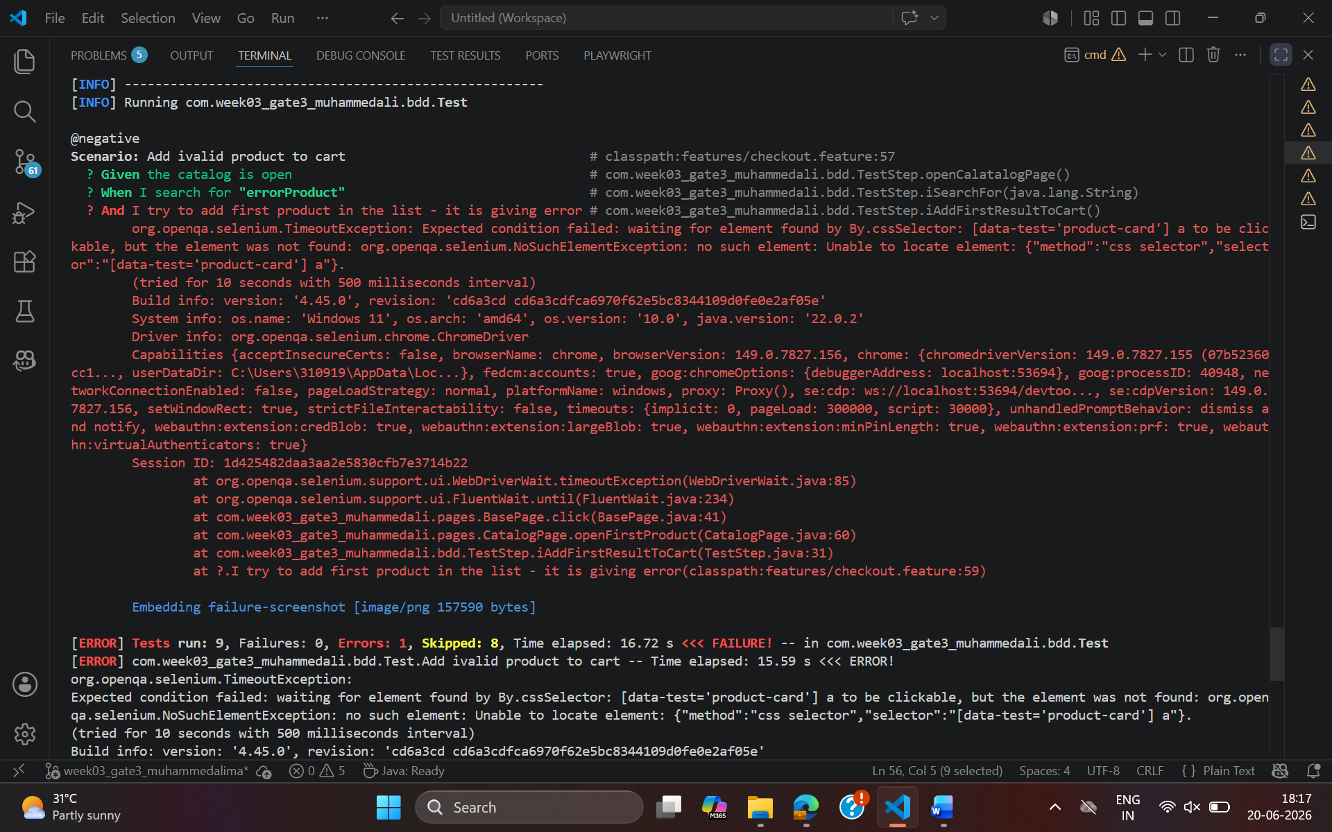
NOTE :
I have added attach.scenario of the cart count if the cart page is used the test cases . the count only will be available if we are using the cartpage
